ALL INDIA INSTITUTE OF SPEECH AND HEARING
अखिल भारतीय वाक एवं श्रवण संस्थान
DEPARTMENT OF SPECIAL EDUCATION
विशेष शिक्षा विभाग
DECEMBER MONTHLY REPORT 2016
- ACADEMIC ACTIVITIES
- Short-term Training Programs: NIL
- Faculty report
- Dr. M. Pushpavathi – HOD in Special Education

- Supervised the work related to Christmas celebration and Christmas fair
- Ccordinated the work related to celebration of International Day of Persons with Disability

- Dr. G. Malar, Reader in Special Education
- CBCS Coordinator & Mentor for I & II B.Ed.Spl.Ed. (HI) – 25 hours
- Coordination & supervision of compensatory & vacation postings
- Coordination for field engagement of II B.Ed. students in schools – including preparation of communication & drafting related documents
- Preparation of practicum schedule for II & IV semesters
- Assistance to Academic Section for preparation of II semester timetable
- Drafting of communication related to C1 & C2 dates with formats for evaluation & distribution
- Coordination of SEA-U Activities – 10 hours
- Coordination of faculty postings
- Compilation of monthly statistics
- Updating spreadsheet for database
- Guidance to Dr. Alok for drafting report for post-school transition
- Preschool Supervision – 15 hours
- Meeting with caregivers in 7groups & follow up of planning & execution of lessons in 10 groups
Classroom observation of 1 session

Name of the Faculty |  | Dr. Alok Kumar | Dr. G. Malar | Dr. Prithi Venkatesh | Dr. P. Vijetha
Clinics
No. of cases evaluated at SEA-U |  | 07 | Screening: 13  Assessment: NIL | 09 | 08
No. of cases supervised individually |  | 0 | 8 children in 1 groups thru’ 1 sessions of classroom observations |  | NIL
No. of groups supervised |  | 04 | 10 | 10 | 13
No. of meeting with parents |  | 02 | 10 |  | 06
Educational Guidance |  | 01 | Clients: 23  Sessions: 25 |  | 01
Academic (Classes not commenced for the month of June 2016)
Classes taken
B.Ed.  Spl.Edn(HI) | Theory |  | NIL
B.Ed.  Spl.Edn(HI) | Practical | 30 hours | 30 hours | Mock teaching observed from 02.12.2016 to 29.12.2016 for IV Semester  Preparation of exercise books for preschool children by II Semester students.
DECSE(HI) | Theory |  |  | 13 classes | 12 classes
DECSE(HI) | Practical
Any other |  |  |  |  | - Served as paper evaluator for UG exams of UOM.  - Served as paper setter for DECSE(IH).  - Coordinated the vacation postings of B.Ed I and II year trainees.  - Supervised the micro teaching sessions of B.Ed II year trainees.  - Followed up with dept. website details and re-submitted on 02.12.2016.  Attended Peer evaluation of TCPD unit on 14th December 2016.
Research
Paper published |  | NIL
Paper in press/ in progress |  | 04 |  | 01
Paper presentation |  |  |  |  | Presented a scientific paper titled “School performance in children with cochlear implants’ in Prof. ULN National Seminar on 18th December 2016 at Vishakapatnam, AP.
ARF Project |  |  | Sanctioned 1 |  | “Efficacy of self learning adapted social studies lessons in Kannada and Telugu for children with hearing impairment at Secondary School Level”.  Duration: One year  Date of commencement: 8th January 2016.  Budget sanctioned: Rupees 3,25,000/  Preparing the final report to be submitted
Thesis Evaluation/Project Review |  | As external Examinar of M.Phil Viva voce
Any other
Meeting held |  |  | 2 monthly meetings with I & II B.Ed. students |  | - On 7th & 8th Dec 2016, meeting was held with the special educators about the upcoming Christmas celebrations.  - On 10th November 2016, meeting was held for health camp with the team members.
Meeting attended |  | 02 | 4 with HOD – Special Education
AV preparation |  |  | NIL
Brochures
Orientation Programme
Workshop |  |  |  |  | Settled the bills related to Workshop held on 9th and 10th October 2016 for 232 teachers deputed.
Roles & Responsibilities
Co-ordination |  | Infant & Toddler Unit | - CBCS Coordinator for I & II B.Ed. Spl.Ed. (HI)  - Mentor for I & II B.Ed.Spl.Ed. (HI)  - Compilation of M.S.Ed. Student Dissertation-based Articles 2014-15  - Intra-Department  - SEA-U  - EduTechLab  Research & Database Unit
Member secretary |  | Preschool | - LD Clinic (in DCS)  - Services for School-Aged Children (in Department of Special Education) | SEA -U | Service for Infant and Toddlers
Member in |  | SEA-U | - TCPD  - Product Development Cell  - Evaluator for UoM UG courses in special educator  Preschool Supervision |  | SEA -U
Mentor |  | M.Sc. -1st Year -Audiology
- Orientation Programs:
Name/Topic of the Program | Coordinator | Objectives | Targeted Audience | Number of Participants | Date
Orientation on Preschool Training for Children with Communication Disorders | Mr.Gururaj D. | Developing awareness on preschools education for Children With Special Needs | Sri Shambulingeshwara College of Physical Education, Pandavapura | 60 students & 3 teachers | 08.12.2016
- Clinical/Special Educational services- Observation Posting of Students from other Institutes: NIL
- Seminars/Conferences/Workshops: NIL
- In- house training Programs: NIL
- Staff Enrichment Programs (SEP’s) : NIL
- Empowering Educators in Education (E³): NIL
- Guest Lectures :
- Invited Talks: NIL
- Development of Materials to Support Learning
- Service in Academic bodies of other Organizations- NIL
- Membership in Professional Organizations/Associations - NIL
- Participation in Committees/Taskforce and Panels setup by other organizations/agencies-
- Any Other (Please Specify).

- RESEARCH ACTIVITIES
- Research Projects
- Completed Research Projects: 01 (ARF)
- New Research Projects:
- On-going Research Project :
- Doctoral and Post-Doctoral Programs: NIL
- Degree Awarded:
- Thesis awarded:
- Thesis Submitted:
- Under Progress:
- Research Papers presented at National/International Conferences/Seminars:NIL
- Research Papers Published(in APA format):NIL
    - Papers published in Conference/Seminar Proceedings
    - Research Papers in press- NIL
    - Research Papers published in Journals:
    - No. of in-house journal articles:
    - Books published.

- Book chapters published(in APA format)
- Books in press :
- Books/Manuals/Seminar Proceedings edited
- Journal Editorship
- Scholarly Reviewing Activities
- Reviewer for Scholarly Journals
- M.S.Ed (HI) Dissertations Guided by Faculty
- SPECIAL EDUCATIONAL SERVICES
- Pre-School Training and Special Education
  - Monthly Statistics Special Educational Services

S. No. | Nature of Services (I/C)
Special Educational Assessment Services (Dr. G. Malar)
 |  | Nature of Special Need  Language |  | ASD / PDD NOS | Hearing Loss |  | Intellectual Disability | Learning Disability | Motor Problems | Multiple Disabilities |  | Others | No. of Clients | No. of Sessions | Total No. of Sessions
1. | Screening & Referral | Kannada |  | 1 | 17 |  | 3 | - | 1 | 3 |  | 2 | 27 | 27 | 36
1. | Screening & Referral | Malayalam |  | 1 | - |  | 1 | 1 | - | - |  | 1 | 4 | 4 | 36
1. | Screening & Referral | Hindi |  | 1 | 2 |  | - | - | - | - |  | - | 3 | 3 | 36
1. | Screening & Referral | Urdu |  | - | - |  | - | - | - | - |  | - | - | - | 36
1. | Screening & Referral | English |  | - | - |  | 1 | - | - | - |  | 1 | 2 | 2 | 36
1. | Screening & Referral | Telugu |  | - | - |  | - | - | - | - |  | - | - | - | 36
1. | Screening & Referral | Tamil |  | - | - |  | - | - | - | - |  | - | - | - | 36
1. | Screening & Referral | Any Other |  | - | - |  | - | - | - | - |  | - | - | - | 36
1. | Screening & Referral | Total No. of Clients |  | 3 | 19 |  | 5 | 1 | 1 | 3 |  | 4 | 36 | 36 | 36
2. | Assessment & Report | Kannada |  | - | - |  | - | - | - | - |  | - | - | - | 07
2. | Assessment & Report | Malayalam |  | - | - |  | - | - | - | - |  | - | - | - | 07
2. | Assessment & Report | Hindi |  | - | - |  | - | - | - | - |  | - | - | - | 07
2. | Assessment & Report | Urdu |  | - | - |  | - | - | - | - |  | - | - | - | 07
2. | Assessment & Report | Telugu |  | - | - |  | - | 1 | - | - |  | 1 | 2 | 7 | 07
2. | Assessment & Report | Tamil |  | - | - |  | - | - | - | - |  | - | - | - | 07
2. | Assessment & Report | Any Other |  | - | - |  | - | - | - | - |  | - | - | - | 07
2. | Assessment & Report | Total No. of Clients |  | - | - |  | - | - | - | - |  | - | - | -
2. | Places from which seen: (1)Karnataka: 23 (2)Kerala: 4 (3)AP: Nil (4)TN: 1 (5)Other Parts of India: 1 – Jharkhand (6)Any other: 1 Dubai, UAE
2. | Age groups seen:(1)Birth to 2.5yrs: 6 (2)2.5⁺ to 6 yrs: 23 (3)6yrs⁺ to 16 years: 6 (4)16yrs⁺: 1
2. | Total No. of Referrals: (1)Educational Assessment: 2 (2)Educational Guidance: 2 (3)PIP: 6 (4)PPEP/ PBC/ GECS: 25 (5)CSS/IEP/NFE/DET: 2 (6) Any Other Services at AIISH: Nil (7) Any Other Services Outside AIISH: 2 (mainstream educational & vocational services)
2. | No. of Reports Issued: (1) Early Development Skills: Nil (2) School Readiness: 1 (3) Curriculum-Based Assessment: Nil (4) Post-School Preparedness: 1
3. | On-going Assessment (as part of service delivery) |  | Figure:  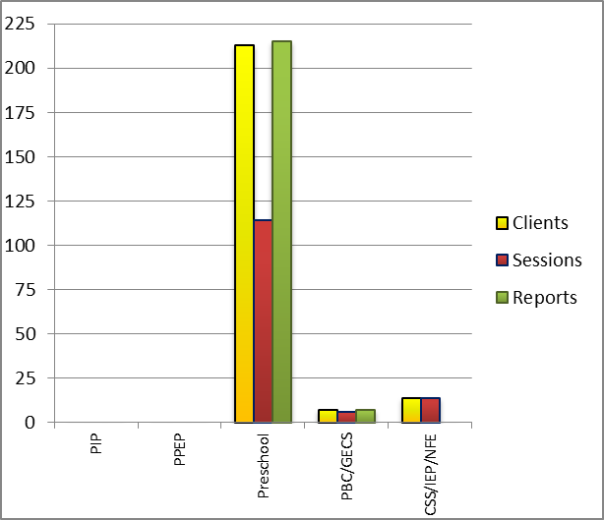
 | Details of Assessments |  | No. of Children |  |  | No. of Assessment Sessions |  |  |  |  | No. of Reports
 | As part of Parent-Infant Programme: |  | Nil |  |  | Nil |  |  |  |  | Nil
 | As part of Preschool Parent-Empowerment Programme: |  | Nil |  |  | Nil |  |  |  |  | Nil
 | As part of Preschool Training Programme: |  | 213 |  |  | 60 |  |  |  |  | 213
 | As part of CSS/ IEP/NFE: |  | 14 |  |  | 14 |  |  |  |  | Nil

Parent-Infant Programme – PIP (Birth to 2 ½ years) – Ms. Leelarani S. B. (Birth to 2 ½ years)
Early stimulation programme for infants & toddlers with communication disorders | Language | HL | ID | CP | ASD | MD | LD | DD | Total No. of clients | Total No. Of sessions
 | Kannada | 09 | - | - | 01 | 7 | - | 2 | 19 | 83
 | Malayalam | 02 | 1 | - | - | 9 | - | 4 | 16 | 33
 | Hindi | 02 | - | - | - | 1 | - | - | 03 | 21
 | English | - | 2 | - | - | - | - | - | 2 | 0
 | Telugu
 | Tamil
 | Total |  |  |  |  |  |  |  | 40 | 137
Specific age range:
No. Of New clients enrolled: 02
No. discharged : 0
No. discontinued: 03
No. of Promoted to next level: 06

Preschool Parent Empowerment Programme – PPEP (Mr. Murshidul Alam):
Buffer programme for children awaiting for preschool admission | Language | HL | ID | CP | ASD | MD | LD | DD | Total No. of clients | No. Of sessions
 | Kannada | 18 | 06 | 00 | 01 | 03 | -- | -- | 28 | 40
 | Malayalam | 01 | 03 | 01 | 01 | 01 | -- | -- | 07 | 36
 | Hindi | 02 | 02 | -- | -- | -- | -- | -- | 04 | 30
 | English | -- | 00 | -- | -- | -- | -- | -- | 00 | 00
 | Telugu | 07 | -- | -- | -- | -- | -- | -- | 07 | 20
 | Tamil | 07 | -- | -- | -- | -- | -- | -- | 07 | 12
Total |  |  |  |  |  |  |  |  | 53 | 138
No. of clients promoted to the next higher level of service: 55
No. discharged : Nil
No. discontinued: 06 (Kannada= 01,Malayalam ID=01, Malayalam ASD=01, Malayalam HL=03)

Services for Preschool-aged Children (2+ to 6 years)
Group Educational Guidance & Counselling Services – GEGCS (Mr.Rajkumar.R): Non-formal preschool training children with communication disorders for schooling | Language | HL | IC | CP | ASD | MD | LD | DD | Total No. of clients | No. Of sessions
 | Kannada | -- | -- | -- | -- | -- | -- | -- | -- | --
 | Malayalam | -- | -- | -- | -- | -- | -- | -- | -- | --
 | Hindi | -- | -- | -- | -- | -- | -- | -- | -- | --
 | English | -- | -- | -- | -- | -- | -- | -- | -- | --
 | Telugu | 1 | 2 | 1 | 2 | 1 |  |  | 7 | 20
 | Tamil | -- | -- | -- | -- | -- | -- | -- | -- | --
Total |  |  |  |  |  |  |  |  | 7 | 20
No. discharged :NIL
No. discontinued: NIL

Curricular Support Services – Supportive training to augment education in mainstream school/ other educational programmes | Language | HL | MR/CP/Down’s/LD | PDD | Total No. of clients | No. Of sessions
 | Kannada | 07 | 13 | 02 | - | 108
 | Malayalam | 02 | 01 | - | - | 18
 | Hindi | 02 | 01 | - | - | 25
 | English | - | 01 | - | - | -
 | Telugu | - | - | 01 | - | 3
 | Tamil | - | - | - | - | -
Total |  |  |  |  | 30 | 154
No. discharged : 02
No. discontinued: NIL
No. New client enrolled: 02

Individualised Educational Programme (IEP) – Training in functional academics for out of school individuals | Language | HL | MR/CP/Down’s/LD | PDD | Total No.of clients | No. Of sessions
 | Kannada | 01 | 02 |  | 03 | 17
 | Malayalam | 01 | 01 |  | 02 | 09
 | Hindi | - | - | 01 | 01 | 08
 | English | - | - | - | - | -
 | Telugu | - | - | 01 | 01 | 03
Total |  |  |  |  | 07 | 37
No. discharged :NIL
No. discontinued: 01
No. Of new clients:01

Non-Formal Educational (NFE) | Language | HL | MR/CP/Down’s/LD | PDD | Total No.of clients | No. Of sessions
supports – Supportive training for children/ adolescents pursuing open schooling | Kannada
 | Malayalam
 | Hindi |  |  | NIL
 | English
 | Telugu

Demonstration Training – Short-term demonstration to caregivers in any of the above | Language | HL | MR/CP/Down’s/LD | PDD | Total No.of clients | No. Of sessions
 | Kannada | - | - | - | - | -
 | Malayalam |  | 01 |  | 01 | 08
 | Hindi | 01 |  |  | 01 | 08
 | English | - | - | - | - | -
 | Telugu | - | - | - | - | -
No. discharged :NIL |  |  | Total |  | 2 | 16

Library of Books & Toys – LiBoToy  (Ms. P. V. Ramanakumari & Ms. P. V. Manjula): Services issuing educational toys & books for home-based training | Total number of members enrolled - 99  No. of new members: - 13  Amount – 650/-  Total number of sessions –26
 | Age group | Total number
 | 0-2.6 yrs | 7
 | 2.6-4 yrs | 6
 | 4.0-6yrs | 77
 | 6 yrs and above | 9

Preschool Training (Ms. Prithi Venkatesh):Preparatory programme for schooling providing training in self-help, cognitive, language and (pre) academic skills, Preschool Bridge course
Language & Disability | No. of Groups | No. of Children
 |  | MALE | FEMALE
Kannada ID, MD, ASD | 14 | 45 | 22
Kannada HI | 10 | 44 | 32
Malayalam HI | 1 | 3 | 2
Malayalam ASD, MD, ID | 10 | 24 | 16
Hindi HL | 1 | 8 | 0
Hindi MD, ID, ASD | 2 | 6 | 2
English ID, ASD | 2 | 5 | 4
TOTAL Number of children |  | 135 | 78
TOTAL No. Groups | 40 | 213
Sessions | 3360 (Group wise) 21 days

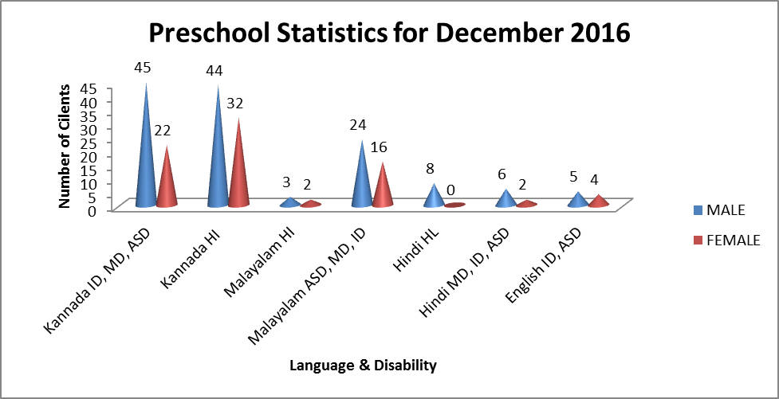

Services | Number of Clients | Number of Sessions
Guidance & Counselling | 32 | 33
Co-Curricular Training | 210 | 26
U-SAFE | 43 | 24

Supports for Empowering Caregivers
Name of Training Unit | No. of Parent  Beneficiaries | No. of Sessions | Content of Training
Caregiver Computer Training Unit | -- | -- | Moving mouse, painting, typing speed, internet browsing
Caregiver Literacy Training Unit | 8 | 12 | Meaningful reading and writing.
- Clinical Support Services to Patients and Family
- Details of Certificates Issued:

Details of Bonafide Certificates Issued:

Sl.No. | Nature of Special Needs in Clients | No. of Certificates Issued | Purpose
1 | DSL,MR | 02 | - For applying financial support from the Government.
- Clinical Electronic Services: NIL
V) CENTRAL FACILITIES
      - Library and Information Services
      - Public Information Activities
- Major Events of the month of December with a brief account: 02

- Name of the Programme/ Event: International Day of Persons with Disability – 50 children with various disabilities from department of special education performed for IDPWD.
- Date: 09.12.2016
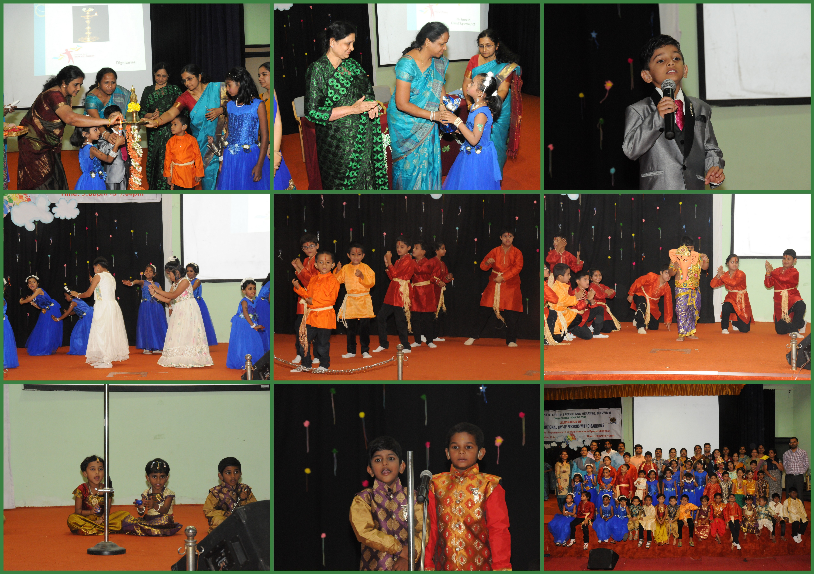

- Name of the Programme/ Event: Merry Christmas & New Year Celebration & Christmas Fair 2016
- Date: 23.12.2016
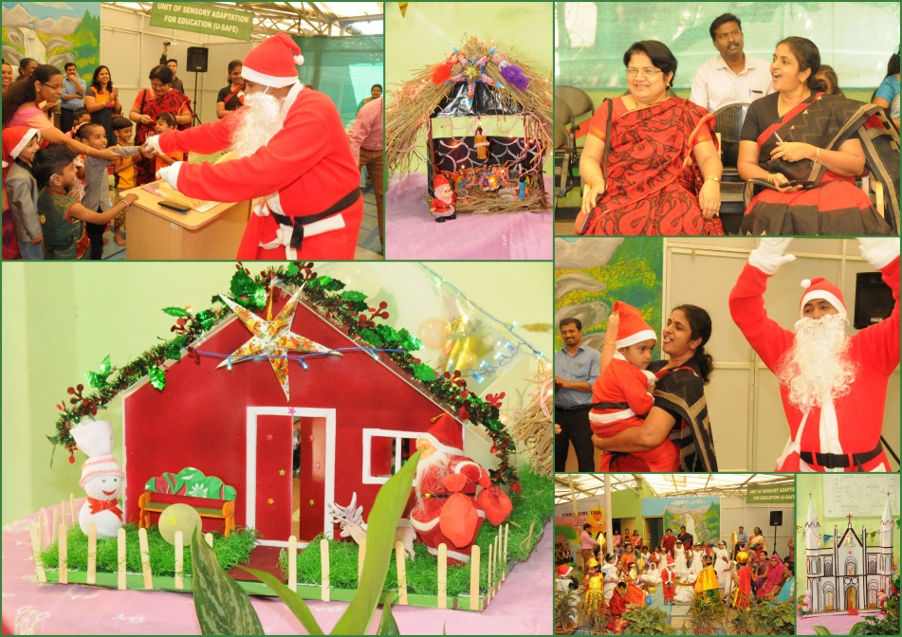

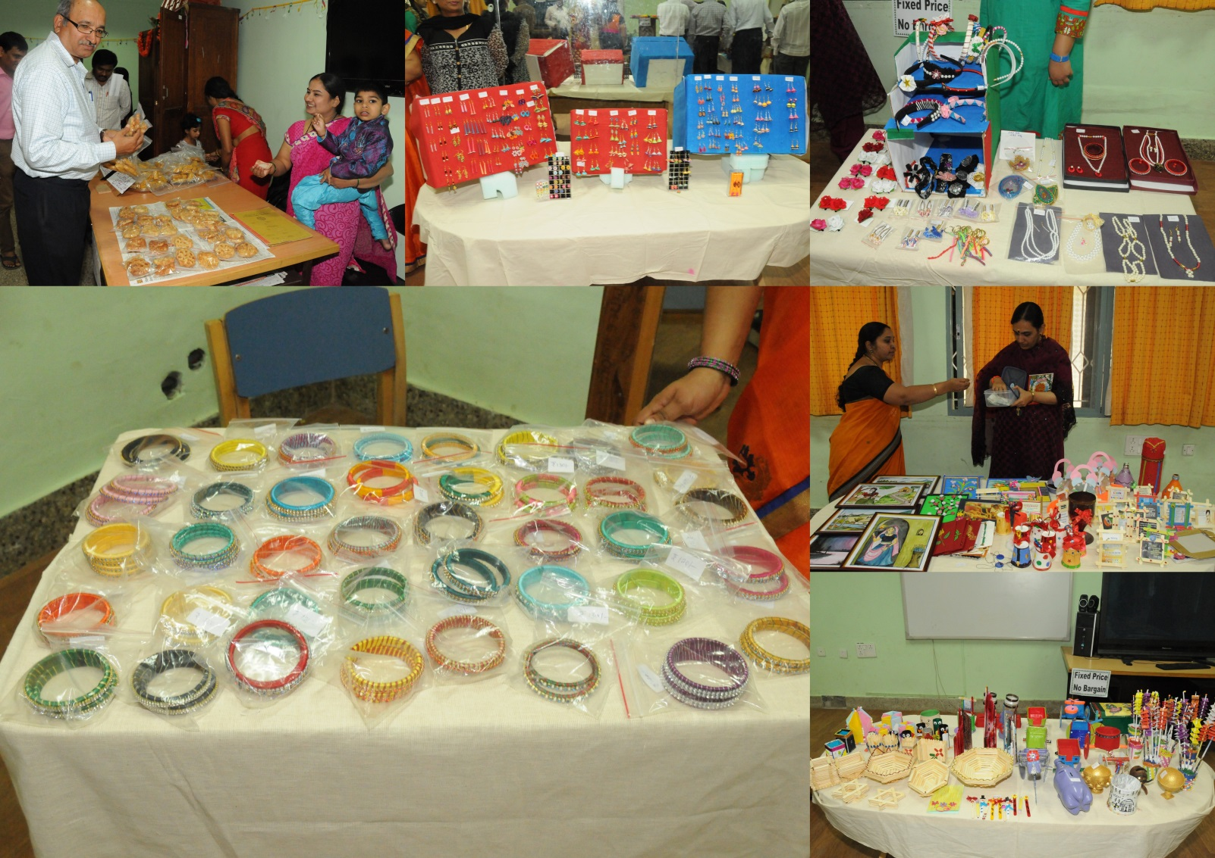

- Press Releases and Media Coverage
- Institute Publications -
- Material Development

Sl.  No. | Nature of Teaching-Learning Materials | Skill | Number
1. | Flash cards | For all skill areas | 248 sets
2. | Work Cards | For all skill areas | 89 sets
3. | Charts | For all skill areas | 4
4. | PPT | For all skill areas | 30
5. | Models | For all skill areas | 6
6. | Sentence strips | For all skill areas | 156 sets
7. | Others | For all skill areas | --
- AWARDS AND HONORS RECEIVED BY FACULTY AND STAFF
- EXTRA CURRICULAR ACTIVITIES
- Others:
IX. EMINENT VISITORS: NIL
X. ANY OTHER
- Official Language Implementation:
- One word a day in Hindi.

Sd/-
Prof. M. Pushpavathi
HOD – Special Education

